**Task :**

**1.** **Enhance your own picture using Numpy and Sklearn?**

***Answer:***

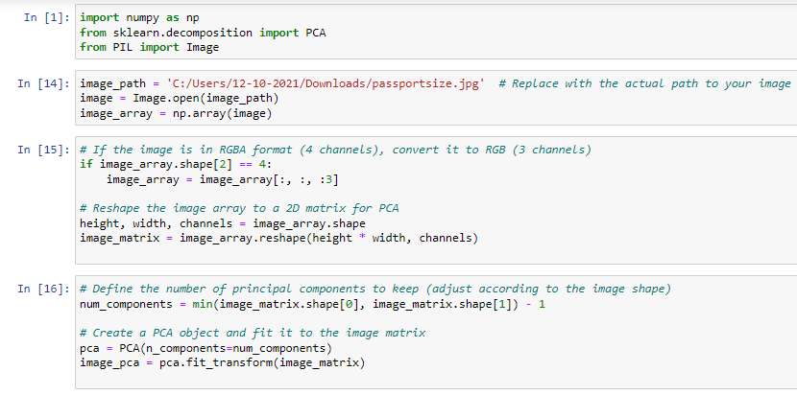 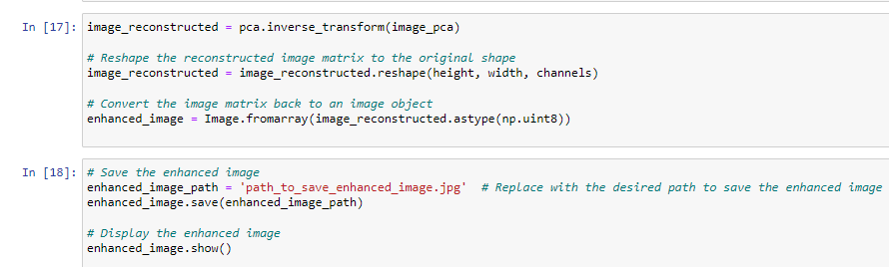

***Before:***

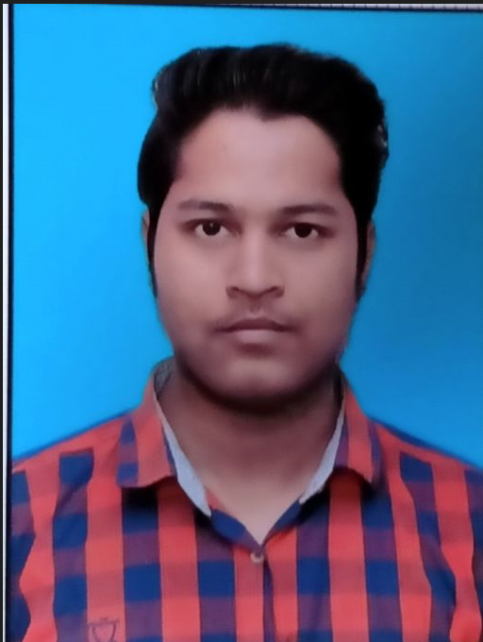

***AFTER:***

